**1.PROBLEM**

**CSS Paddings - using div**

Mayura, the most leading expert in designing websites has been booked by the HiGlobe Organizers for designing a web page which displays the incites about the events organized by them. During the webpage creation, Mayura intended to add some CSS properties within the div element for making the alignment of the web page attractive using padding properties. Please help her to complete the webpage using CSS padding properties.

**Hints :**

The CSS padding properties are used to generate space around an element's content,inside of any

defined borders.

**padding**

To shorten the code, it is possible to specify all the padding properties in one property.

Syntax :

padding : one to four values;

**Content :**  
outer div  
inner div with class  - first  
h3 - Corporate Events  
p - Event Management of team building events that develop and motivate teams in companies and corporations. Team building events are perfect for companies and their divisions to motivate their employees and to develop real teams.  
  
outer div  
inner div with class - second  
h3 - Wedding Planning  
p - We provide Wedding Event Management Service as per requirements of customers. These services are rendered by professionals who have several years of work experience.  
  
outer div  
inner div with class - third  
h3 - Award Ceremony  
p - Awards ceremonies are a celebration of talent, success and achievement. We've pulled together some of the things you need to consider when organising an awards ceremony.  
  
outer div  
inner div with  class - four  
h3 - Asian Party  
p - With our residents line-up, beautiful staff, and the best crowd in Amsterdam, John Doe has something for everyone. Listen to the best music under the huge led ceiling.  
  
  
**Constraints :**  
The count of <div> tag must be 8.  
Apply the following padding style for the inner div tags:  
first - 15px 13px 0px 0px  
second - 50px 100px 25px 70px  
third - 50px 45px 0px 40px  
four - 25px 0px 25px 258px  
  
**Note :**  
Content of the page should be present as shown in the screenshot.  
Kindly refer the content which is given as a part of description.  
  
**Sample Screenshot 1 :**  
  
Before applying padding  style  
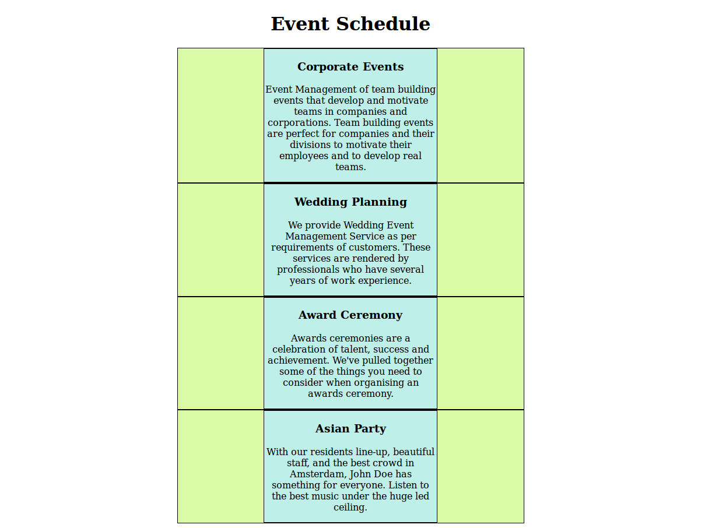  
**Sample Screenshot 2 :**  
  
After applying padding  style

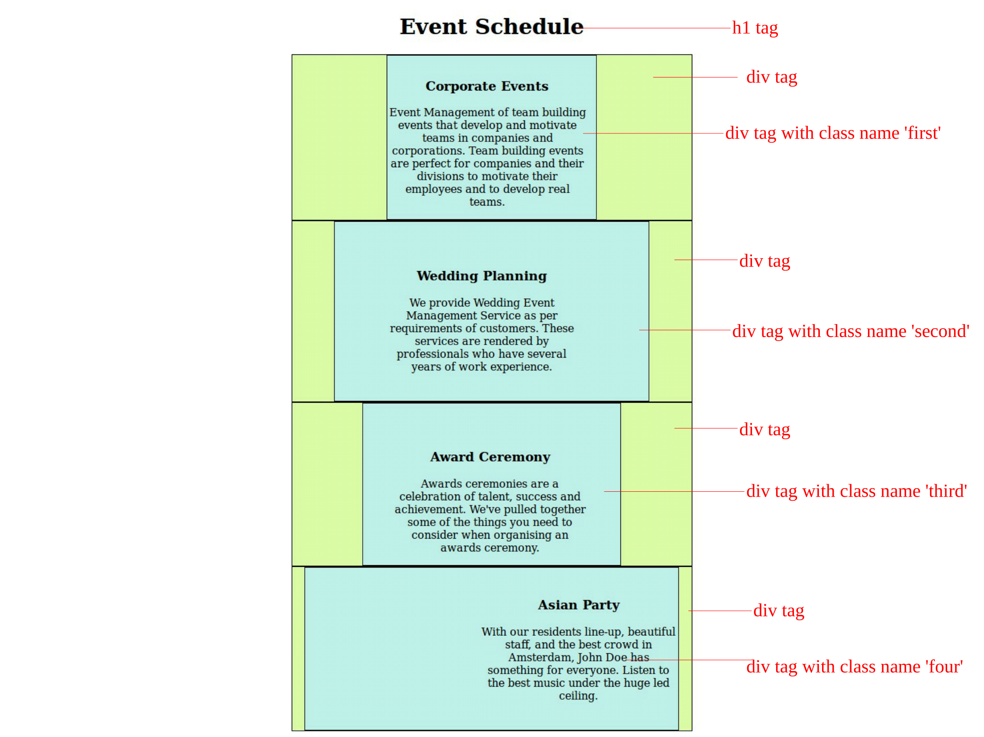

**2.PROBLEM**

**Lists - position attribute**

Jacqueline is pursuing her undergraduate degree at Carmel Academy. She is a studious student and very much interested in Web Designing course. Seeing her interest in the subject, her Lecturer Stella insisted her to take a seminar for her classmates on a simple topic in CSS.  
  
She chose the seminar topic to be on position attribute in CSS and started collecting notes for the same. She was willing to explain her classmates with a sample webpage containing the usage of position attribute which would lead to the progressive technique of learning. She is preparing the delivery content and so wants your help to create a sample webpage explaining the usage of position attribute in CSS.

**Hints :**  **list-style-position property** The list-style-position property specifies if the list-item markers should appear inside or outside the content flow. **inside** Indents the marker and the text. The bullets appear inside the content flow. for eg: 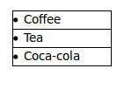 **outside** It Keeps the marker to the left of the text. The bullets appears outside the content flow. This is default. for eg: 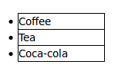 **inherit** The inherit keyword specifies that a property should inherit its value from its parent element. Syntax : list-style-position: inside|outside|initial|inherit;

**Content :**

h1 -Pink Frag Event Organizer  
<hr>  
h3 - Wedding Events  
ul class - "wedding"  
li  
Photography  
Music band  
Henna artist  
Beautician  
h3 - Corporate Events  
ul class - "corporate"  
li  
Grand Openings  
Seminars  
Meetings  
Team Building  
h3 - Social Events  
ul class - "social"  
li  
Birthday party  
Surprise party  
Dinner party  
Garden party  
Use list-style-position attribute for having different positions.  
In ul tag with class wedding  
Give list-style-position as outside and background-color  as  #FFA500  
In ul tag with class corporate  
Give list-style-position as inside and background-color as  #9ACD32  
In ul tag with class social  
Give list-style-position as inherit and background-color  as  #ff9999  
Give all li background-color as #6fafaf   
  
**Constraints :**  
Do not use inline style attribute.Use Internal styles.  
Tag 'ul' must be present for minimum of 3 times in the html page.  
Tag 'li' must be present for minimum of 4 times each ul tag in the html page.  
Tag <ul> with class name must be present in the html page as given in the content.   
The headers and the background-color should be same as as given in the content.  
The list-style-position should be the same as given in the problem content.  
The Content in the tags should be the same as given in the problem content.   
  
**Note :**  
Content of the page should be present as shown in the screenshot.  
Kindly refer the content which is given as a part of description.  
  
**Sample Screenshot 1 :**  
  
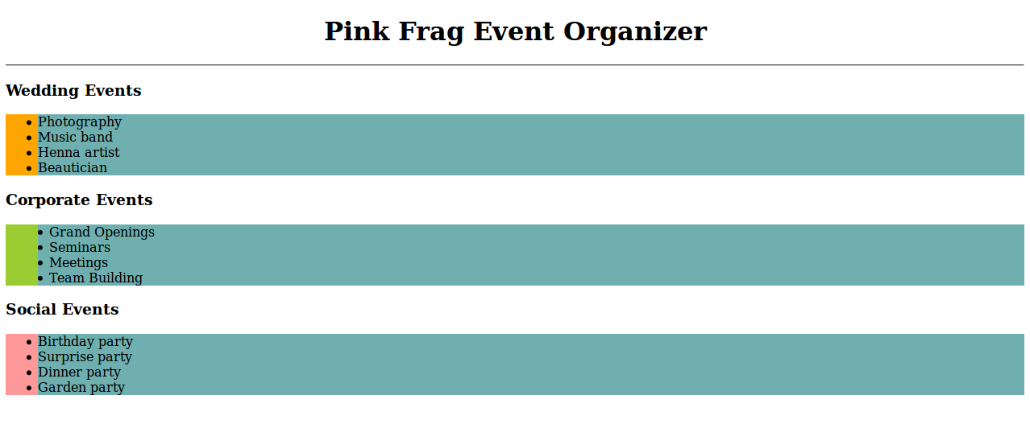  
  
**Sample Screenshot 2 :**  
  
